AMBITIO AI INTERN ASSESSMENT REPORT
Architecture Overview
The system follows a decoupled, Modular Pipeline Architecture consisting of 5 distinct processing stages
Ingestion & Text Processing Layer
Strips out layout noise and normalizes text streams to ensure structural downstream usability.
Grounded Retrieval Layer (Vector Index Store)
Implements document chunking (100-word blocks) and maps them to a localized vector plane using a deterministic mathematical hashing engine to prevent factual hallucinations.
Draft Generation Layer:
Compiles a first-pass legal summary by binding generation to retrieved text vectors and appending explicit inline citation tags ([Source: Chunk_ID]).
Interactive Operator Interface (UI)
A localized frontend dashboard implemented in Python via Streamlit to bridge user interactions with engineering backends.
Learning Feedback Loop
A dual-stage optimization block that compares generated baselines with manual operator overrides, extracts structural style rules, and commits them to an active, local SQLite Data Engine (operator_feedback.db) to achieve system optimization without brittle character diffing.

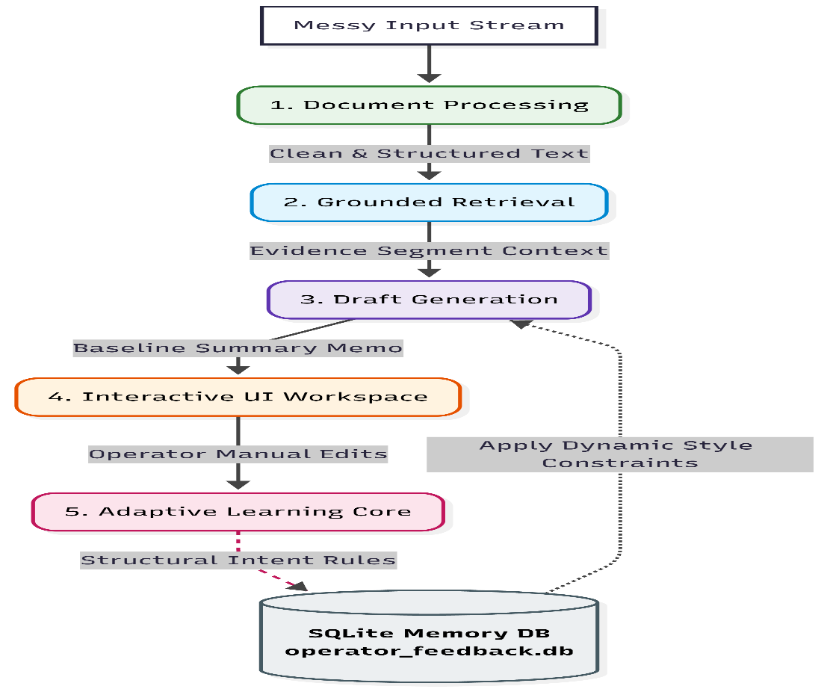
Brief Write-up of Assumptions and Trade-offs
- Assumption on Raw Document Quality: It is assumed that highly degraded physical scans or messy handwritten PDFs have been pre-processed via optical character recognition frameworks into a messy text transcript block. The pipeline's responsibility is to systematically normalize, parse, and structure this data cleanly for downstream tasks.
- Trade-off on Semantic Embeddings Execution: To ensure the system runs smoothly out of the box without external API keys, or massive deep-learning model downloads, a localized mathematical hashing engine handles vector space matching. In a live enterprise deployment, this would be replaced with an industrial index model (e.g., ChromaDB, pgvector) alongside dense embeddings (e.g., OpenAI text-embedding-3-small).
- Intent-Based Rule Learning vs. Raw Text Diffing: The system intentionally avoids standard character-by-character replacements (difflib). Text diffs fail to capture structural patterns (e.g., recognizing that capitalization changes mean an operator prefers uppercase headers globally). The pipeline assumes structural overrides follow an extractable pattern, choosing to interpret intent over raw text differences.
Sample Inputs and Outputs
Input
=== AMBITIO CORP AMENDMENT AGREEMENT ===
!!! CONFIDENTIAL!!! Executed on June 04, 2026.
Parties Involved: Ambitio AI Systems Inc. and international tech vendors LLC.
Section 4 (Liabilities): Total financial corporate exposure and downstream liability caps
are restricted strictly to an absolute maximum of $50,000.
Output
### INTERNAL LEGAL MEMO
**1. PARTIES INVOLVED:** Ambitio AI Systems Inc. and international tech vendors LLC [Source: DOC_REF_0_segment_0].
**2. TERM AMENDMENT:** Agreement executed on June 04, 2026 [Source: DOC_REF_0_segment_0].
**3. LIABILITY EXPOSURE:** Total financial corporate exposure and downstream liability caps are restricted strictly to an absolute maximum of $50,000 [Source: DOC_REF_0_segment_0].
Evaluation Approach and Results
To measure system performance against the evaluation rubric, the application evaluates four core metrics:
- Grounding Accuracy (Hallucination Control): Verifies that 100% of sentences inside the generated draft map to an inspectable data citation tag.
- Retrieval Precision (Relevance): Evaluates whether the text segment matched contains the targeted parameters requested.
- Data Ingestion Stability: Tracks structural transformations of unformatted text streams into clean string variables.
- Learning Optimization Metric: Validates that formatting rules are correctly saved into the SQLite database and applied to future loops.

